CSE 490
Combined Lab
(DHCP/NAT/PAT) ID___________
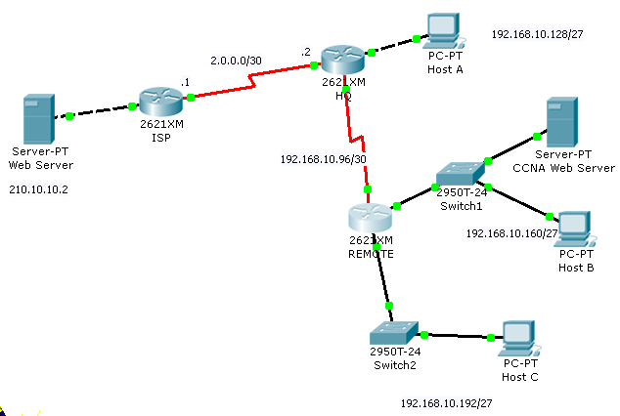
Device | Interface | IP Address |  | Host IP Addresses
ISP | Fa0/0 | 210.10.10.2/30
ISP | S0/0 | 2.0.0.1/30
-HQ | S0/0 | 2.0.0.2/30
-HQ | Fa 0/0 | 192.168.10.158/27 | Host A- | 192.168.10.129/27
-HQ | Lo1 | 10.10.10.1/32
-HQ | S0/1 | 192.168.10.98/30
REMOTE | S 0/0 | 192.168.10.97/30
REMOTE | Fa 0/1 | 192.168.10.190/27 | Host B- | DHCP Assigned
REMOTE | Fa 0/1 | 192.168.10.190/27 | CCNA Web Server | 192.168.10.161/27
REMOTE | Fa 0/0 | 192.168.10.222/27 | Host C- | 192.168.10.193/27
Note:
No configuration is required for the ISP Router. OSPF routing protocol is already configured on both HQ and REMOTE routers.

Configuration Tasks:
DHCP:
- Configure REMOTE Router as a DHCP Server for the 192.168.10.160/27 network only. The CCNA Server should have a static address of 192.168.10.161. The first five addresses and the last address should be excluded from the pool. Pool name is REMOTE_POOL1.
- After configuration check the IP assignment of Host B via DHCP. What is the IP address of Host B?
________________________________________________________________________
- Ping between hosts to check connectivity. Successful?
________________________________________________________________________

NAT/PAT
- Configure HQ router as a NAT server to dynamically assign global outside IP addresses from the NAT pool (name: hqpool) 212.16.32.128/29 to local inside packets attempting to access the Internet. The first public address 212.16.32.129/29 should be statically assigned to the CCNA server. Then any packet with an IP address from the 192.168.10.128/27, 192.168.10.160/27and 192.168.10.192/27network will be translated with the rest of the pool addresses using PAT. (ACL number should be 1).
- Verify connectivity by pinging the web server from host A, Host C and Host B.
- Using show commands verify the nat translations. Write down first two entries.
___________________________________________________________________________
___________________________________________________________________________

